OOAD ASSIGNMENT PART A

BY:CSE24-161 ,Abigail Mototegi

REQUIREMENT ELICITATION

INTERVIEW MINUTES

AGENDA-Requirement Elicitation.

DATE-18 September 2025

TIME-10:00 AM & 10:30-12:15

INTERVIEWER-Mr Moeng and Mr Baseki

INTERVIEWEE-Abigail Mototegi

QUESTIONS

1.What are the main functionalities the system should have?

Answer: The system should be able to register customers and open accounts for them namely savings, cheque and investment account.

-Customers should be able to log in into the system.

-Customers should be able to view account(s) balance.

-Customers can open multiple accounts.

-The system should provide transactional history.

-The system should add interest to applicable accounts.

-The customer should be able to withdraw on applicable accounts and deposit.

2.Who will be the main users of the bank system? Individuals or companies?

Answer: Both should be able to open multiple accounts.

3.Who is responsible for validating and registering customers?

Answer-the bank system.

4.What happens if someone wants to close or freeze account?

Answer: They would have to first withdraw the money and also get charged for closing the account but for now that is a scope creep for us lets stick to the functions I have mentioned.

5.In terms of non-functional requirements is there a particular look u want to maintain?

Answer-No. We are giving u free reign to be creative but in terms of usability the system should be user-friendly.

6.Should they be a specific currency we should stick to?

Answer-No the idea here is to gain knowledge and get the system working.

EXPANDING THE REQUIREMENTS FROM THE INTERVIEW

FUNCTIONAL REQUIREMENTS

-Registering customers and Log in

\*The system should register customers who want to open accounts by capturing their details e.g name, surname, address and employer if applicable and use those credentials to log into the system.

\*The system should validate the log in credentials.

-Account opening and transactions

\*The customer should be able to open multiple accounts with the bank.

\*Rules for the type of account chosen should be followed e,g depositing less than the stated minimum 500 t0 a check account to give an error message.

\*The customer should be able to do withdrawals, deposits and view balance.

-Transaction History

\*The system should provide a tab for all transactions for the chosen account for the customer to view.

-Interest Calculation

\*The system should calculate interest for the savings and investment accounts

\*The cheque account does not have interest.

NON-REQUIREMENTS FUNCTIONALITIES.

USABILITY

\*The system interface should be easy to use and understand.

PERFORMANCE

\*Transactions should not take long to make and reflect.

\*The system must calaculate interest quickly.

SECURITY

\*Log in should require a private password.

\*The system should validate and store data securely.

ACCOUNTS RULES

1.savings account-Withdrawls are prohibited and interest of 0.25% monthly.

2.Cheque account-Withdrawals and deposits can be made.

3.Investment account-Deposits and withdrawals can be made and and interest of 0.5% monthly.Needs an initial deposit of 500

CLASS DIAGRAM

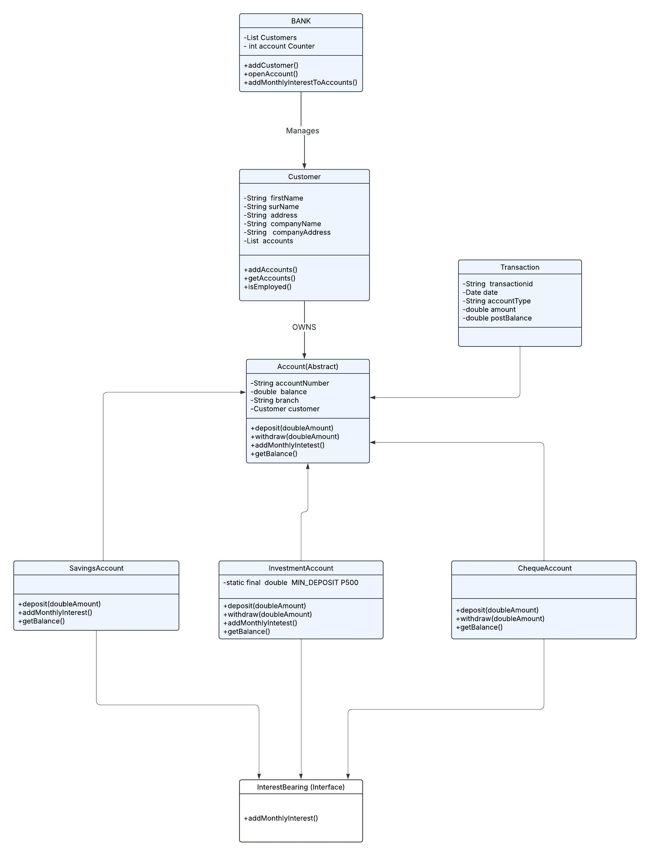

USE CASE SCENARIO

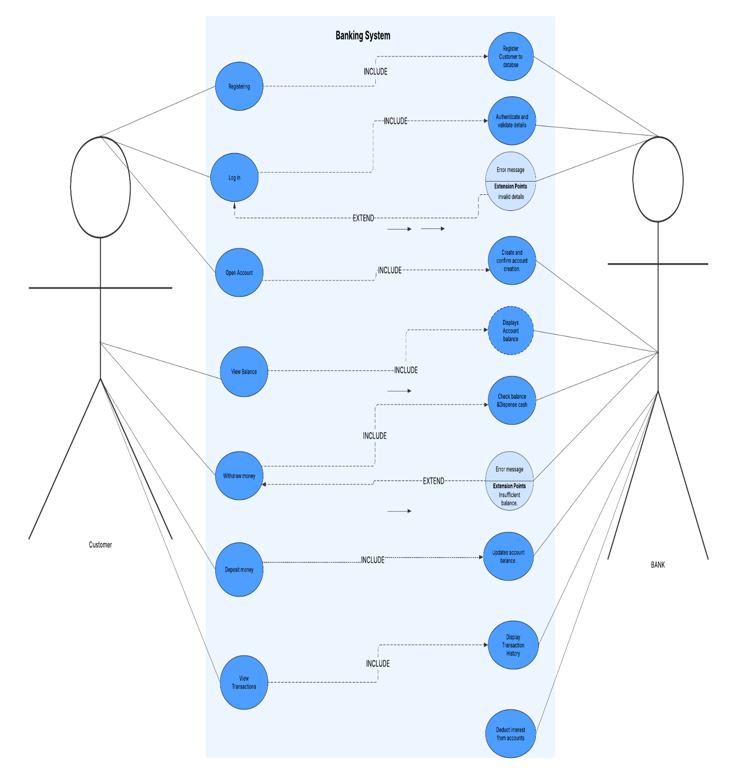SEQUENCE DIAGRAM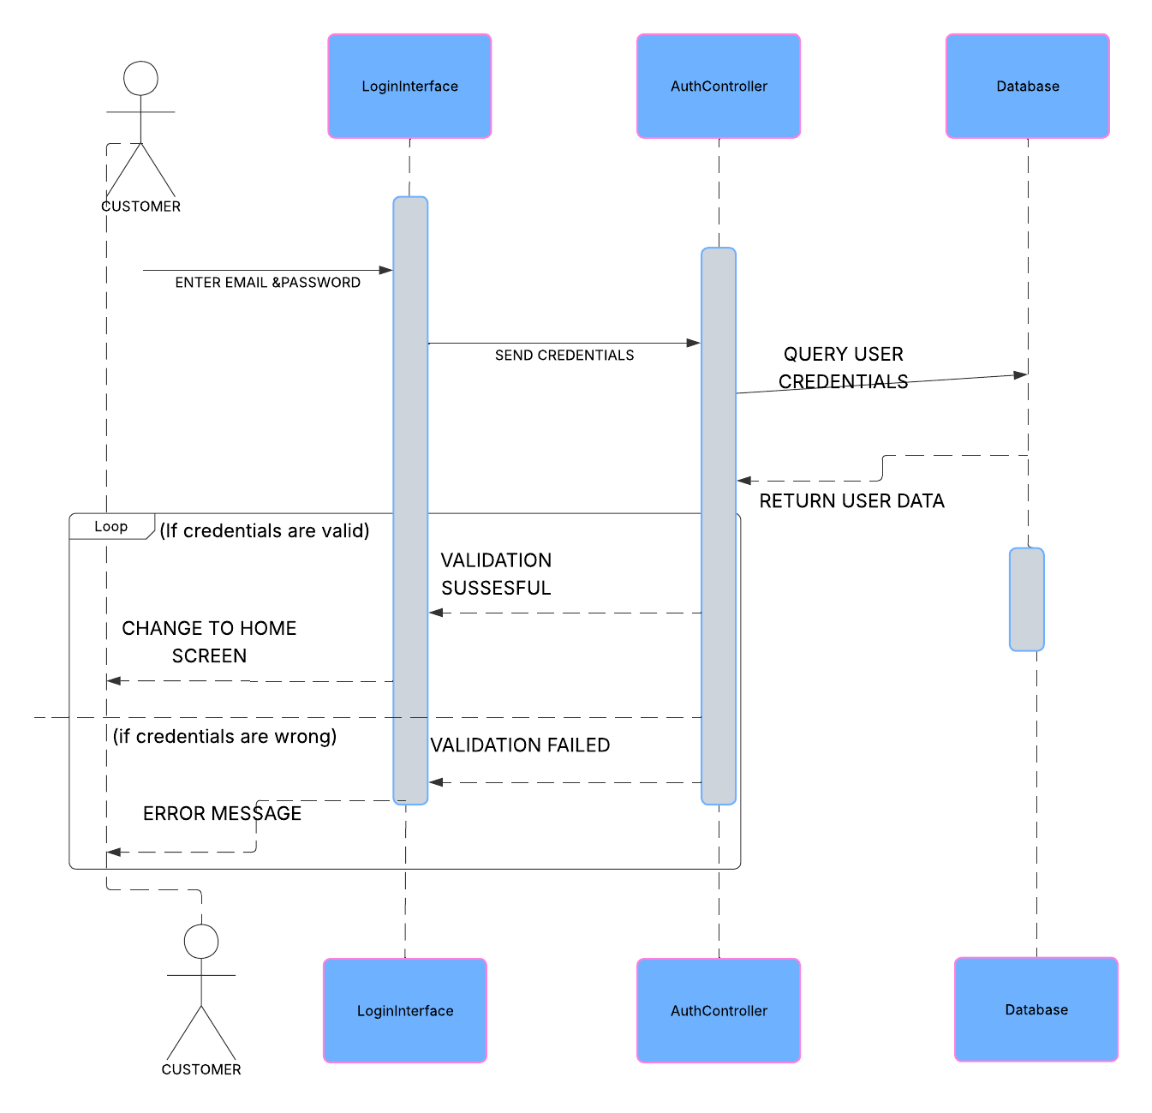

STATE DIAGRAM

